ROBOT WITH NAVIGATOR AND OBSTACLE AVOIDANCE – OVERVIEW AND ANALYSIS

ECSE 211 – Design Principles and Methods

Design Evaluation

Our robot is equipped with 2 large EV3 motors. In deciding between the EV3 and NXT motors, we evaluated that the precision and accuracy provided by the EV3 motor would be much more appreciated for a lab that required a high precision for measurements. We equipped our robot with a ultrasonic sensor at 0 degrees looking forward ahead of the robot. A beam runs across the back of the robot in order to deal with the wiring of the motors. Lastly, a gyro ball was added at the middle of the back of the brick in order to support the front wheels. Our robot was equipped with ability to navigate to certain waypoints and avoid objects as well.

Figure 1: Design of our robot

Figure 2: Implementation flow chart

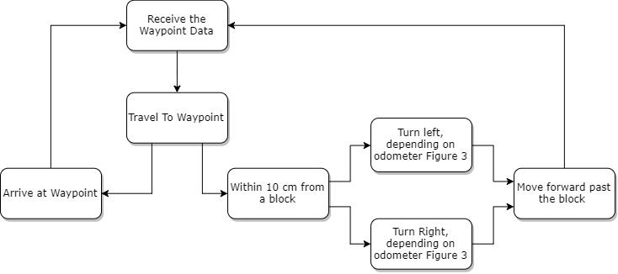

Figure 3: Ultrasonic Navigator conditional statements

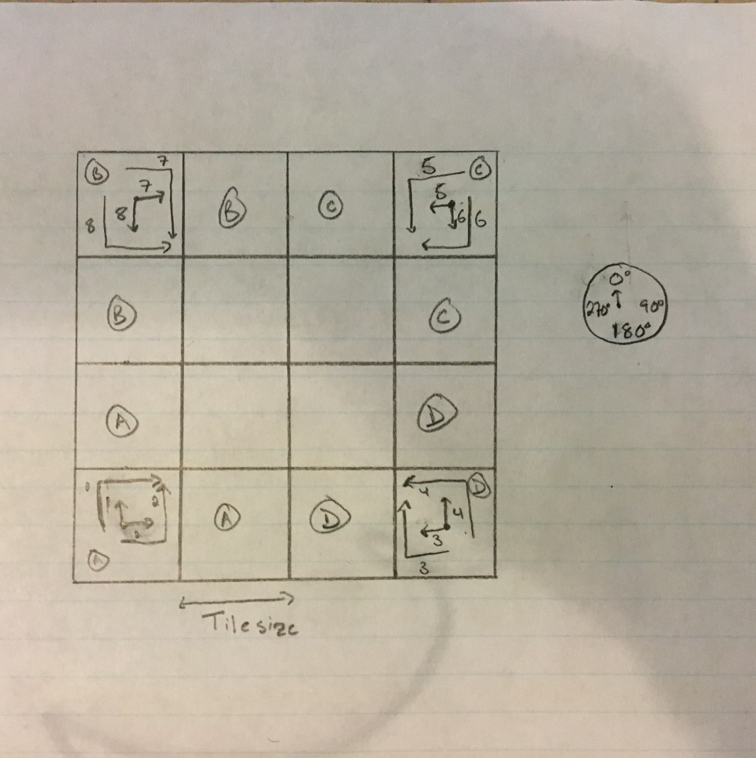

Our implementation utilized its position to determine the correct turn to execute on the platform in order to avoid the block. The algorithm first determines its orientation from theta. From here it will look whether he x and y coordinates are greater than a tile size (30.48 cm). Using this data, we can determine which quadrant our vehicle is located and which direction it is facing. Therefore, we can process which turn is ideal for such scenario.

Figure 4: Software diagram

Test Data

To test the navigator’s accuracy, we measured the robot’s position and noted the position reported by the odometer 10 independent times after the robot had navigated to the following waypoints: (2,1), (1,1), (1,2) and (2,0). Table 1 details the position of the robot and its theoretical position according to its waypoints.

Table 1: Navigation Results

|  |  |  |  |  |  |  |  |
| --- | --- | --- | --- | --- | --- | --- | --- |
| **Navigation** | | | | | | | |
| **Run #** | **Theoretical X XA ± 0.05 cm** | **Theoretical Y YA ± 0.05 cm** | **Actual X XA ± 0.05 cm** | **Actual Y YA ± 0.05 cm** | **Error X EX ± 0.05 cm** | **Error Y EY ± 0.05 cm** | **Euclidean Error** |
| 1 | 62.0 | 0.0 | 61.1 | 63.4 | 0.85 | -1.40 | 1.6378 |
| 2 | 62.0 | 0.0 | 63.9 | 59.6 | -1.90 | 2.40 | 3.0610 |
| 3 | 62.0 | 0.0 | 62.7 | 60.5 | -0.75 | 1.45 | 1.6325 |
| 4 | 62.0 | 0.0 | 59.9 | 60.8 | 2.10 | 1.20 | 2.4187 |
| 5 | 62.0 | 0.0 | 61.0 | 60.2 | 0.93 | 1.75 | 1.9818 |
| 6 | 62.0 | 0.0 | 60.8 | 62.6 | 1.20 | -0.65 | 1.3647 |
| 7 | 62.0 | 0.0 | 60.3 | 62.6 | 1.65 | -0.60 | 1.7557 |
| 8 | 62.0 | 0.0 | 62.9 | 63.0 | -0.95 | -1.05 | 1.4160 |
| 9 | 62.0 | 0.0 | 62.5 | 60.3 | -0.50 | 1.70 | 1.7720 |
| 10 | 62.0 | 0.0 | 64.4 | 60.9 | -2.40 | 1.10 | 2.6401 |
|  |  |  | **Mean (cm)** | | 0.023 | 0.59 | 1.968031 |
|  |  |  | **Standard Deviation (cm)** | | 1.536215046 | 1.367438806 | 0.560105 |